VIJAY SOCIAL WELFARE SOCIETY

ABOUT US

**VIJAY SOCIAL WELFARE SOCIETY was** registered on January, 2017 in the name of late Shri Vijay Shankar Tare who selflessly helped others throughout his life.

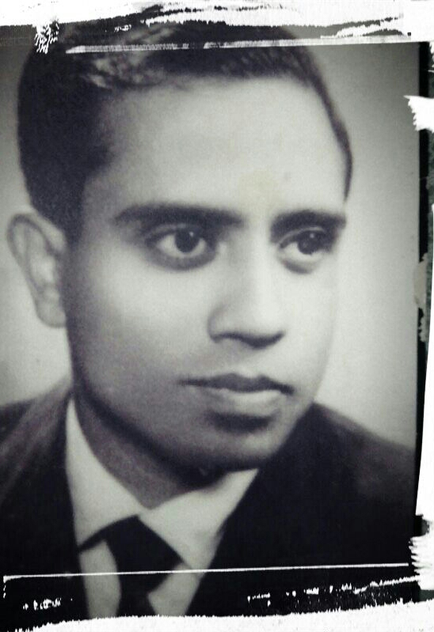

It is a nonprofit organization that not only serves mother earth but also unprivileged sections of the society. Through awareness, development, relief and advocacy, we strive to dedicate our resources & devote our time & beliefs to impact as many lives as we can in contexts of environment, health, education & vocation.

|  |
| --- |
| ***A diverse team united by a common objective*** |
|  |
| VSWS team includes media professionals, corporate professionals, workers, activists, CAs, civil servants, bankers, consultants, teachers and all such people who voluntarily bring their experience, expertise, and perspective to the organization. What unifies them is the common aim of conserving the environment & creating a promising future for unprivileged women, children & youths of our country. |

Vision

At VSWS, we are committed to our vision to help create better environment in terms of ecology as well as health, happiness and creative womanhood, childhood & youth.

Mission

Our mission is to develop concern, awareness & a sense of answerability towards environment & to shed some light on the situation of the deprived women & children so as to motivate them to seek resolution through individual and collective action thereby enabling them to realise their full potential.

**We aim to achieve measureable impact by taking the following steps:**

Connecting with Local Communities

Through interactions, workshops, seminars and trainings with communities, we make people aware of the need to protect the environment, the need to have proper education & skills to bring about a better living for themselves and their children.

Creating Awareness

We sensitise people on issues that affect environment, women & children through various channels of communication. We also form and participate in networks and alliances to lobby for the common cause we believe in.

Getting Public Aid

We generate funds and resources (voice, time, skills) from individuals and through institutional partnerships. We encourage people from all walks of life to join us to contribute in creating an environment in which they can lead a healthy & happy life.

Enabling Change

Thus, VSWS works towards ensuring a green and healthy environment for all where men, women & children live, learn, play, express them to bring about lasting change in their lives.

**SUPPORT AND DIGNITY**

We believe that in this era of unsustainable development, every individual deserves a future that they can believe in. At VSWS, we ensure the same by protecting nature & providing them respect, human touch, basic health care, free food and dry ration through a compassionate approach. On every festival we distribute essential commodities to the people of deprived sections of the society. We also conduct various workshops for their skill enhancement.

**Donate**

“The test of our progress is not whether we add more to the abundance of those who have much; it is whether we provide enough for those who have little.”

A small deed of kindness can greatly change the lives of hundreds of needy ones.

**You can donate**

* Small sweet box
* Crayons, Colour Books, Pencils, Sketch Books
* Water Bottles, Small Plates, Mugs
* Small Biscuits Packets, Tetra Pack Juices, Soft Toffees, milk powder
* Toys, Kids Clothes, Storybooks (new or old but in good condition)
* Books, note books, school bags etc.

**Our Ongoing & Upcoming Projects are:**

1. UDAY: Organising guidance & counselling workshops by renowned faculties to help students in choosing proper subjects, career& proper educational institutes.

2. SANKALP: Arranging classes for skill enhancement such as Spoken English, Personality development, Etiquettes & Manners, Body Language etc., sanskar shivirs for slum children to develop values & also to create awareness regarding ill effects of drug addiction. Arranging workshops by eminent personalities for self defence & vocational training to girls & women.

3. PRITHVI: CARE FOR ENVIRONMENT- planting saplings& safeguarding them, short talks on need & importance of garbage segregation& its proper disposal, making eco-friendly items.

4. UMANG: Distributing essential commodities like stationery items, clothes, bags, foot wear, story books, toys etc.

5. NIROG: Providing health care, counseling and referral services for illness and diseases, awareness regarding personal hygiene during menstruation, sex education etc

6. AAHAR: Avoiding wastage of food during wedding & other events.

7. Muskan: Ensuring admissions of underprivileged children in Govt. and Private schools to support govt in 100% literacy mission.

SUMMER ACTIVITIES 2017

1. **Career Guidance Workshop** - On 21 May 2017 we conducted free career and guidance seminar in Khargone (M.P.) for underprivileged children. Mrs.Jayshree Patel, a renowned Counsellor was the spokesperson on this event. Around 350 students attended the workshop.

2. Bal Sanskar Shivir - On 23 May 2017 we conducted Bal Sanskar Shivir for 40 children of slum area of shiv nagar, Indore.

3. - On 26 May 2017 we distributed certain essential commodities such as garments, stationery, books and eatables to 100 people of slum area.

Upcoming Projects

4. Plantation Drive - On 5 June 2017 we have planned to plant 1900 Peepal trees at Mandsaur (M.P.)

On 2 July 2017 our group is joining Narmada Plantation Project and we are planning to plant 100 trees in Indore and 100 in Khargone district.

On 3 september Plantation with tree guards in three schools of Alok Nagar, Indore.

5. Self Defence Workshop - We are also planning for Self defence work shop for women & girls of slum areas.

6. Art & Craft Workshop – A workshop will be conducted to train women & children to make eco friendly items.

In place of vinita write Tilottama

Go through www.shuddhi.org and smile foundation There is one information regarding Partners NGO plz include that in our website also Our partners r Nanhi udaan, Chhav group, shri vande foundation and vihaan samajik sanstha Get involved campaign, volunteer, fund raise , donate , shop Just add presidents pic with our punch line let's do good

[contactvijay.2017@gmail.com](mailto:contactvijay.2017@gmail.com)

Address B-57 LIG colony RSS nagar Indore (M.P.)

9300774806 9303229658